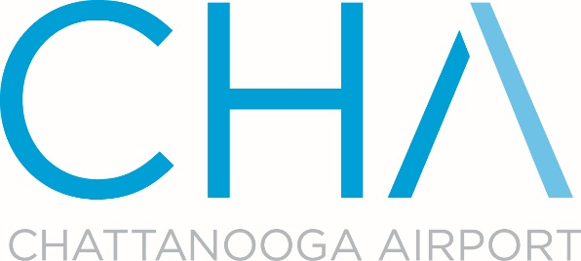

Chattanooga Metropolitan Airport Authority
Terminal Janitorial Services
RFP Addendum 1

The following sets forth questions, answers and clarifications resulting from the RFP process. The Authority’s responses are in BLUE.

The Authority hereby clarifies that addenda issued pursuant to this RFP will be posted on the Airport’s website and sent via e-mail to the Participants who submitted questions.

Addendum No. 1 is published on May 17, 2019 as follows:

Additional clarification:

- What is the square footage of the Chattanooga Metropolitan Airport Terminal?

Approximately 60,000 square feet

- Does the Chattanooga Metropolitan Airport supply uniforms?

No- We prefer you wear your own uniforms

- Is there a bid bond required to submit a proposal?

No

- Here is the Revised Bid Sheet - Due back by May 23, 2019 at 2:00 p.m. Eastern Standard Time

- Can you disclose who the current contractor is and price being paid?

Current contractor is MaidPro at an hourly rate of $20.50

- The scope of work detailed on page 4 of the RFP has been modified to add the CT-80 rooms. Pre-Security Areas, Ticketing, Baggage, Claim/Car Rental, Escalator/Stairwell, Elevator, Gift Shop, Airport Lobby, Library, CT-80 Rooms

